
ST. MARTIN’S
SCHOOL SHOP GUIDE

Type bit.ly/stmartinsshop in to your web browser search bar.
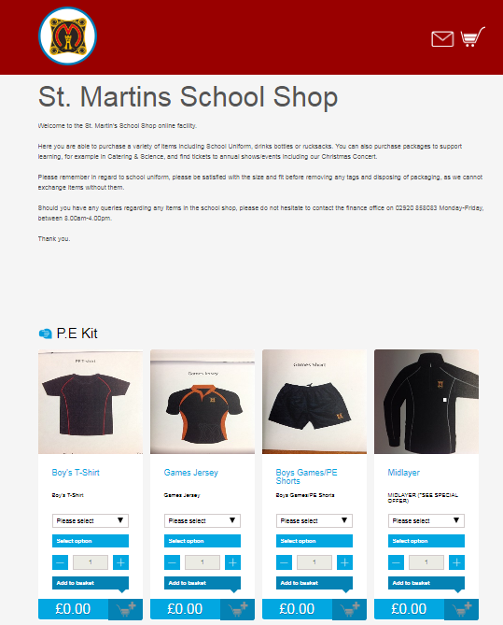

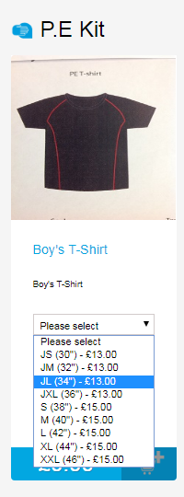

Using your order form for size guidance please select the correct sizes for each item needed.
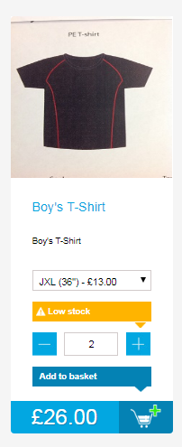

Select the quantity of each item.

Click the cart icon to add the item to your basket.

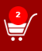
Once you’ve selected all items, click the cart icon in the top right corner of the page.
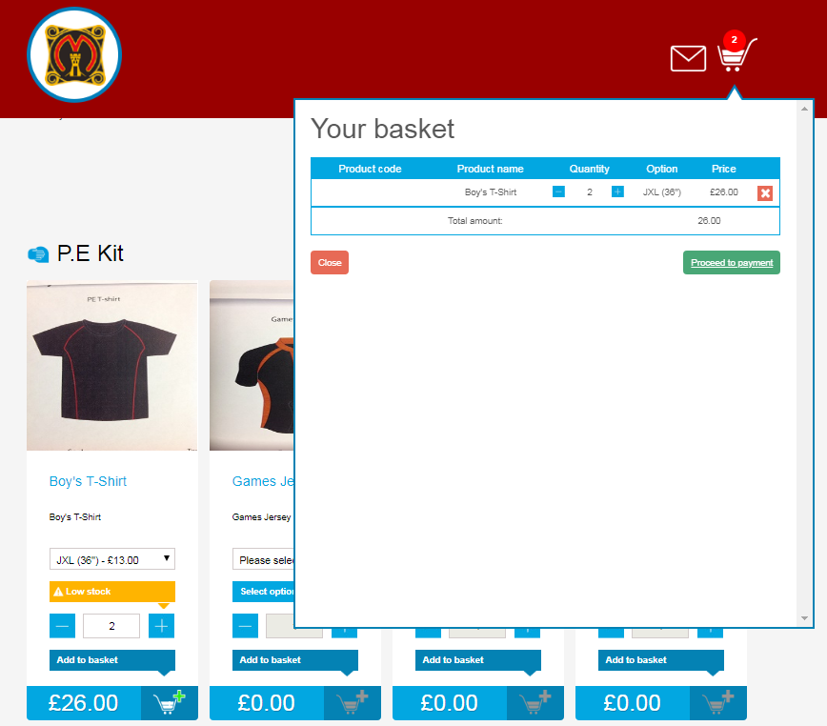

Click ‘Proceed to checkout’

Enter parent details - We will use the email provided in this section to let you know once your order is ready to collect.
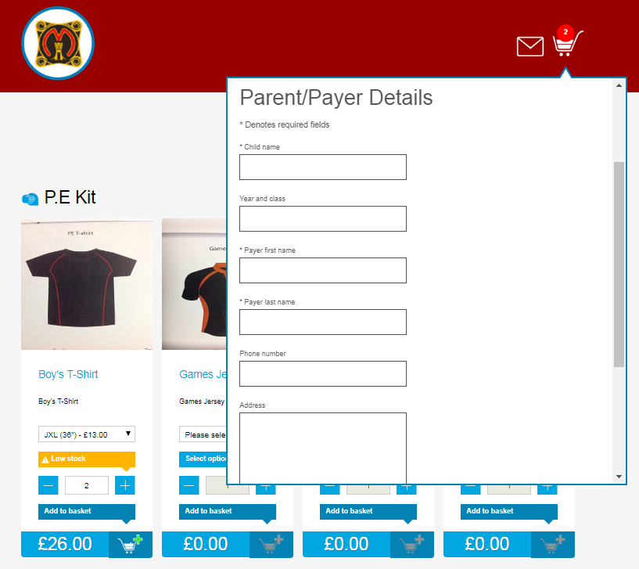

Proceed to payment page to complete your order.


