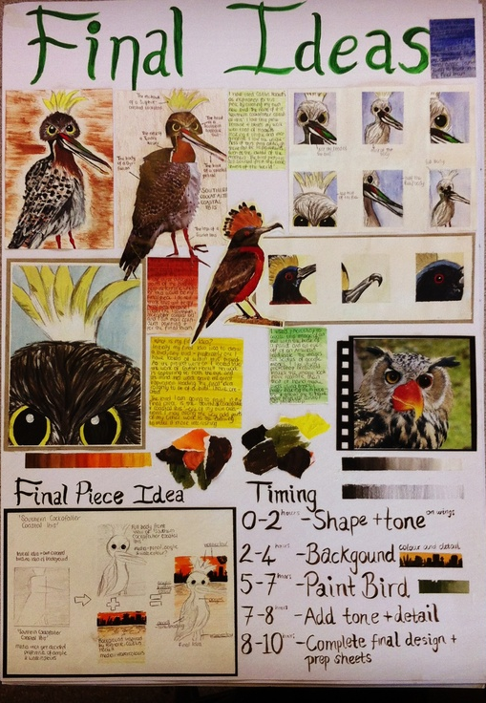
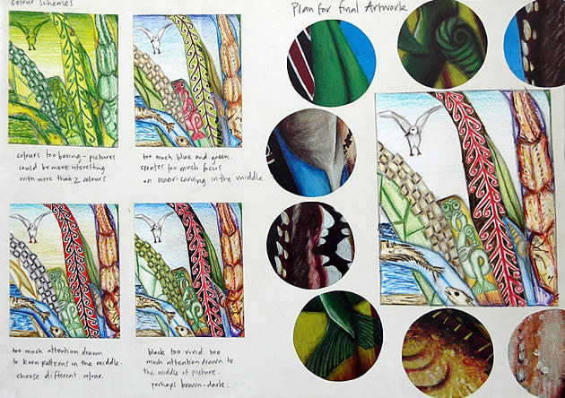
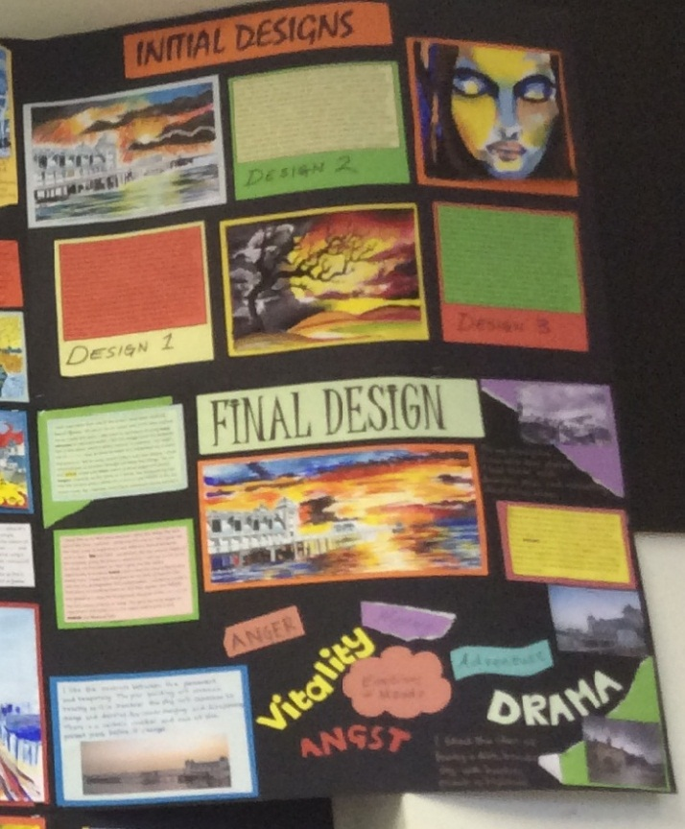
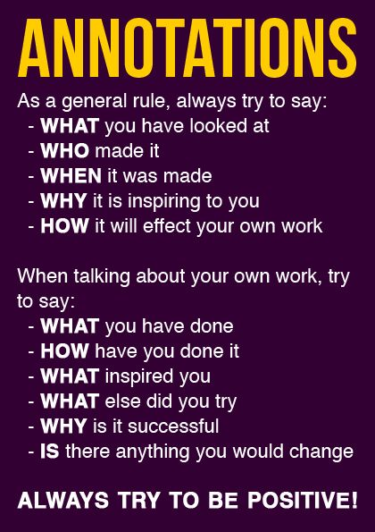
Revision for ART
Before the Art Exam pupils will have initial designs linking to the Artists’ work they have studied and experimental work that they have carried out and a final design with annotation so they are prepared for the two day exam where they make their final outcome.

