

How to Revise GCSE APPLIED BUSINESS

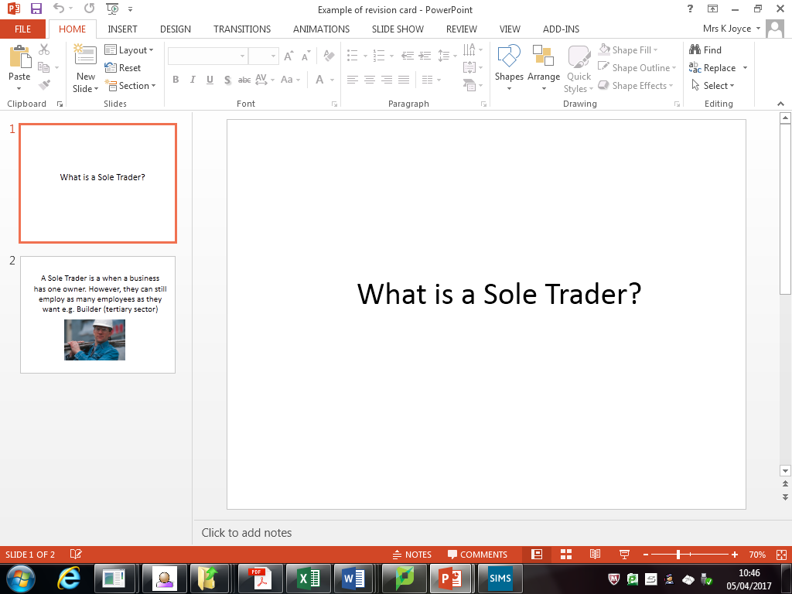
Use flash cards to help you to remember key terms. Get other people to test you. REPETITION is key here. You should have these in your folder already.. if not check out W:\BUSINESS STUDIES\Year 10 Business\REVISION CARDS for additional examples and suggested “terms”
Ques on one side; term on the other

Remember! Questions that start with “On a business you have studied…”
You need to select :
- Business name and
Correct Business Ownership e.g Tesco PLC
- Type of business activity e.g. Tertiary Sector
NO APPLICATION = NO MARKS!
Create mind maps and posters of module! Or use Mind Maps already created for you!
W:\BUSINESS STUDIES\Year 11 Business\Mind Maps

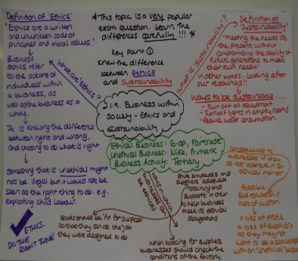
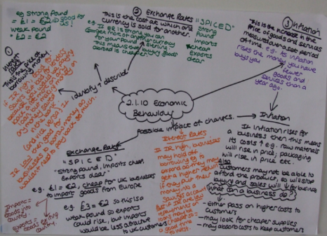
Try these revision quizzes to gauge your understanding before and after you have revised the topic:
https://www.tutor2u.net/business/blog/business-studies-revision-quizzes

Keep trying Past Papers (A241)! Mark against Mark Scheme; Reflect, and TRY AGAIN!
Shared Drive in school: W:\BUSINESS STUDIES\Year 11 Business\Past Papers and Mark Schemes
OCR Website: http://www.ocr.org.uk/qualifications/gcse-applied-business-single-double-award-j213-j226-from-2012/

Use this link to find past papers and mark schemes:
http://www.wjec.co.uk/qualifications/qualification- resources.html?pastpaper=true&subject=EnglishLiterature&level=gcse

