

How TO REVISE for Spanish

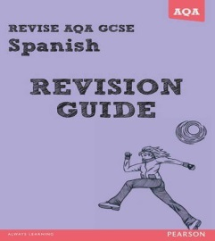
Use vocabulary games to help with your revision; handout on Google classroom. 11A (LDo) code = bnoa8c and 11Y (LDo/FL) code = xvtq56.
Past Paper tips:
- Read each text twice.
- Highlight what the question is asking.
- Highlight marks.
- Practise using Google classroom; codes above.
- Use sticky tabs/highlighters to RAG your revision of vocabulary.
Create mind maps and posters of each module of Mira – see PDF on Showbie.

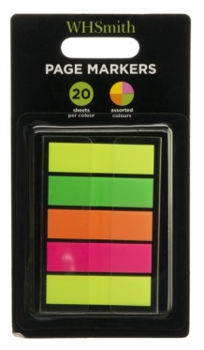
Use this link to find past papers and mark schemes:

Use these apps to help you:
www.quizlet.com www.memrise.com www.duolingo.com www.fluentu.com
Listen to Spanish music in preparation for the listening:
https://www.youtube.com/playlist?list=PLax9Qu1tWy91LeYmLi4uMBh-dfSGD6yOT


