

How to Revise for English LITERATURE

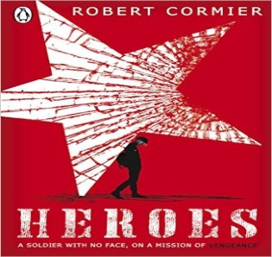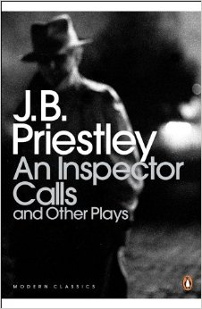
Read the texts again, highlight and underline key quotes. Use coloured sticky tabs to identify pages with effective quotes. Create a key to identify which quotes relate to which character or theme
Use flash cards to help you to remember key quotes. Get other people to test you. REPETITION is key here
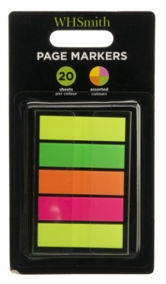
Create mind maps and posters of each character and theme

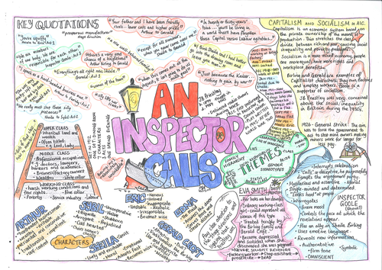
Use this link to find past papers and mark schemes:
http://www.wjec.co.uk/qualifications/qualification- resources.html?pastpaper=true&subject=EnglishLiterature&level=gcse
Search for FREE revision apps on the app store
Watch an inspector calls online here:
https://www.youtube.com/watch?v=Vukp3EFVweQ

Use these websites to help you:
http://www.sparknotes.com/drama/an-inspector-calls/
Y:\Heroes - master presentation.pptx

