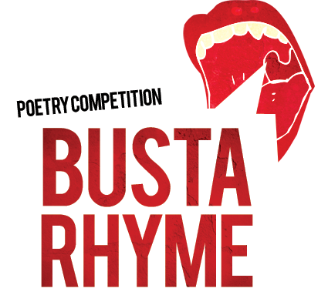
A massive well done to all of the students who entered the Busta Rhyme poetry competition set by the Young Writers and have had their work selected for publication.
Letters have been handed out to pupils in school or sent home requesting parental/guardian signatures in order for their fantastic poems to be published. Please make sure that these forms are returned to the company so that work can be published in the forthcoming book, which you also have the opportunity to buy should you wish to do so.
We look forward to seeing your work and name down in print in this new collection. A huge thank you to the fabulous English Department at St. Martin’s for encouraging pupils to develop their written talents.

